

Affiliated to

**INDIAN INSTITUTE OF TECHNOLOGY,**

**KHARAGPUR**

**A Project Synopsis**

**On**

**Bank Management System**

Submitted for the award of Project of

**Bank Management System**

**By:**

Kulal Aditya Gajanan

Lokre Digvijay Shivaji

In

Year 2023 – 2024

Mr. Abishek Chavle Dr. Pavan Goel

**Project Guide**  **Computer Eng. Department**

**Table of Content**

|  |  |  |
| --- | --- | --- |
| **Sr. No.** | **Contents** | **Page No.** |
| 1. | Objective | 3 |
| 2. | Introduction of Project | 4 |
| 3. | Project Module | 5 |
| 4. | Project Plan (Gantt chart) | 6 |
| 5.. | Project Requirement | 6 |
| 6. | System Design | 7 |
| 7. | E-R Diagram | 8 |
| 8. | Conclusion | 9 |
| 9. | Bibliography | 9 |

**Objective –**

The objective of a bank management system is to effectively and efficiently manage the operations and resources of a bank. It aims to facilitate the smooth functioning of various banking processes and provide a reliable platform for customers, employees, and administrators to carry out their respective tasks.

* Here are some specific objectives of a bank management system:

1. Customer Service: The system aims to enhance customer service by providing convenient and user-friendly interfaces for various banking activities such as account management, funds transfer, loan applications, and customer support. It should enable customers to access their accounts, perform transactions, and obtain information easily and securely.
2. Operational Efficiency: The system strives to improve the overall operational efficiency of the bank by automating routine tasks, streamlining processes, and reducing manual efforts. It should facilitate quick and accurate transaction processing, minimize errors, and optimize resource utilization.
3. Risk Management: A bank management system aims to assist in effective risk management by implementing robust security measures, fraud detection mechanisms, and compliance controls. It should ensure the confidentiality, integrity, and availability of sensitive financial information while adhering to regulatory requirements.
4. Financial Management: The system helps in financial management by providing real-time access to financial data, generating reports, and analyzing financial performance. It should support functions like account reconciliation, cash management, liquidity management, and financial forecasting.

Overall, the objective of a bank management system is to optimize the bank's operations, enhance customer satisfaction, minimize risks, and facilitate informed decision-making to achieve sustainable growth and profitability.

**Introduction –**

A bank management system is a comprehensive software solution designed to facilitate the efficient and effective management of banking operations and resources. It serves as a centralized platform that integrates various functionalities and processes within a bank, enabling seamless communication, streamlined workflows, and enhanced customer service.

In today's fast-paced and technology-driven banking industry, a robust bank management system is crucial for maintaining a competitive edge and meeting the evolving demands of customers. The system combines advanced technology, data management capabilities, and banking expertise to support the day-to-day operations of a bank while adhering to regulatory requirements and ensuring data security.

The introduction of a bank management system marks a significant shift from traditional manual processes to automated and digitized operations. It replaces cumbersome paper-based tasks with efficient digital workflows, enabling faster transaction processing, accurate record-keeping, and improved customer experiences.

The primary objectives of a bank management system are to optimize operational efficiency, enhance customer service, mitigate risks, and enable informed decision-making. By automating routine tasks, such as account management, fund transfers, and loan processing, the system frees up valuable time for bank employees, allowing them to focus on more complex and value-added activities.

**Project Module:**

1. **Signup Module:**

This is used to signup into our system. By using this username & password can enter into our project.

1. **Login Module:**

Through this module we enter into our project. By using username and password we login the project.

1. **Create Account Module**

This module create new account of user in a bank. In this module 3 options are include for create new account i.e: customer name , customer new account number & initial balance.

1. **Deposit Module**

User use this module for deposit money in their account. In this module 2 options are include for deposit the amount i.e: account number & how many amount user deposit in their account.

1. **Withdraw Module**

With the help of withdraw module user withdraw amount . In this module 2 options are include for withdraw the amount.

1. **Display Details Module**

This module shows the details of the user. On the basis of correct account number it shows the details of user.

1. **Update Module**

Some time wrong data entered by the employee that time update module is worked.

1. **Close Module**

This module is use for close the account of user , if he/she want to close.

**Project Plan:**

**Gantt chart:**

|  |  |  |  |  |  |  |
| --- | --- | --- | --- | --- | --- | --- |
| **Sr.no** | **Task Name** | **09-jun** | **11-jun** | **15-jun** | **17-jun** | **19- jun** |
| **1** | **Requirement Gathering** |  |  |  |  |  |
| **2** | **Planning** |  |  |  |  |  |
| **3** | **Designing** |  |  |  |  |  |
| **4** | **Coding** |  |  |  |  |  |
| **5** | **Testing and Deployment** |  |  |  |  |  |

**Project Requirements:**

* **Hardware Requirements:**

1. Processor: p4 and above
2. RAM: 512mb and above
3. Hard Disk: 5 GB or above
4. Input device: keyboard, Mouse
5. Output device : Monitor or LCD/LED, Printer

* **Software Requirement:**
* Frontend-IDE: Visual studio 2008
* Language : Python
* Backend-Database: MS SQL Workbench 8.0 CE

**System Design:**

* + - * + **System Design :**

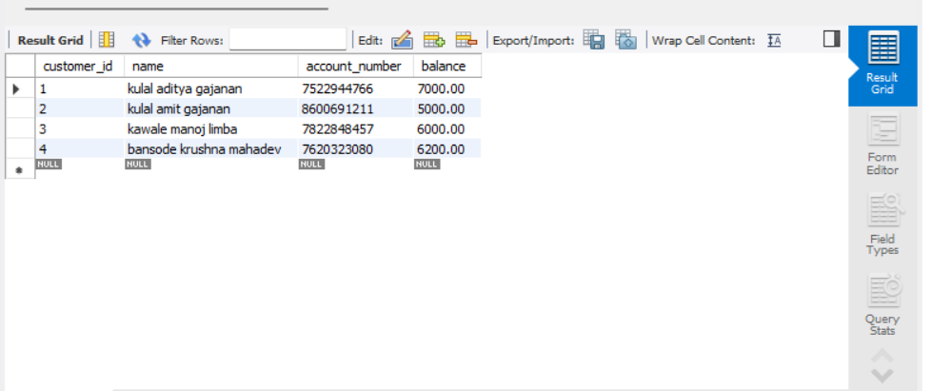

**E R Diagram:**

Login

Signup

Bank Facilities

to

User

**Conclusion:**

The bank management system code provided is a basic implementation that allows users to sign up, log in, create customer accounts, deposit and withdraw funds, update customer data, display customer details, close customer accounts, and display bank details.

The code utilizes MySQL database for data storage and retrieval, and it establishes a connection to the database using the mysql.connector library. It includes error handling for incorrect login credentials, insufficient funds during withdrawals, and customer/account not found scenarios.

* **Bibliography –**

* Books:

1. "Bank Management and Financial Services" by Peter S. Rose and Sylvia C. Hudgins
2. "Bank Management" by Timothy W. Koch and S. Scott MacDonald

* Website:
  + 1. MySQL Documentation: <https://dev.mysql.com/doc/>
    2. GeeksforGeeks: https://www.geeksforgeeks.org/banking-system-2/